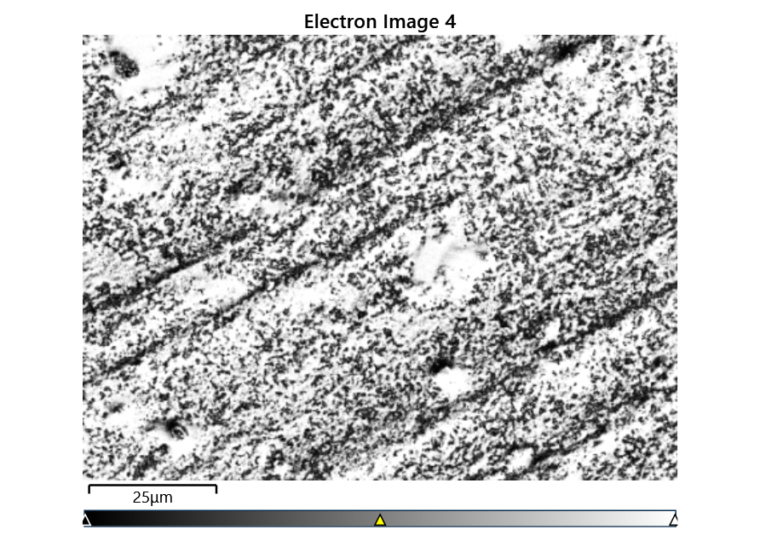



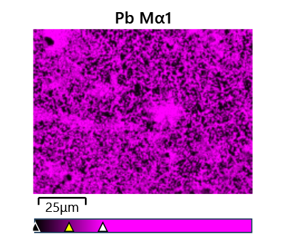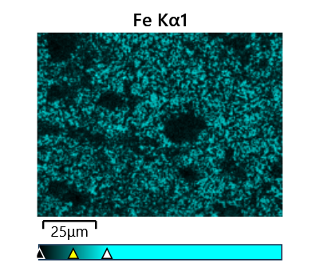

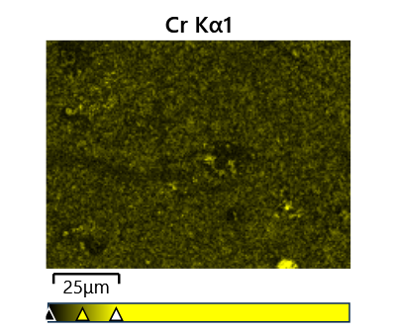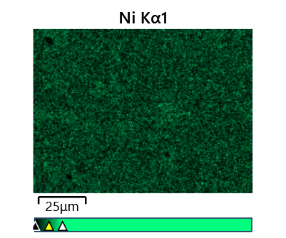

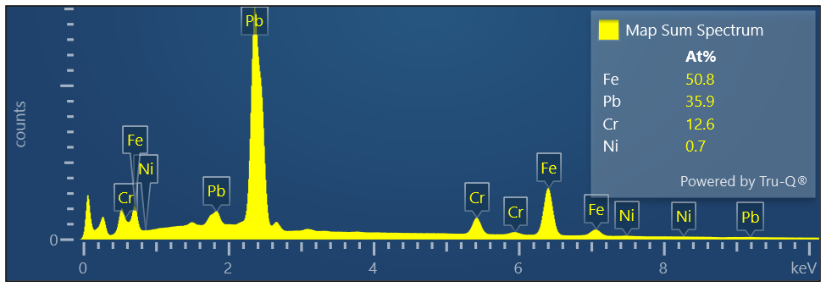

Map Sum Spectrum

Element Signal Weight % σ

Pb 67.81 0.05

Fe 25.84 0.04

Cr 5.99 0.02

Ni 0.37 0.03

**Map Sum Spectrum**

**Element Signal Atomic % σ**

**Fe 50.77**

**Pb 35.91**

**Cr 12.63**

**Ni 0.69**